Experiment 5: write a Python program to solve the Missionaries and Cannibals Problem

Aim
To write a Python program to solve the Missionaries and Cannibals Problem using the Breadth First Search (BFS) algorithm.

Algorithm
- Represent the state as (Missionaries Left, Cannibals Left, Boat Position).
- Start from the initial state (3, 3, 1) where the boat is on the left side.
- Generate all valid next states by moving one or two people across the river.
- Reject states where cannibals outnumber missionaries on either side.
- Continue exploring valid states using BFS.
- Stop when the goal state (0, 0, 0) is reached.
- Display the sequence of states from the initial state to the goal state.

Program
from collections import deque

def is_valid(m, c):
if m < 0 or c < 0 or m > 3 or c > 3:
return False
if (m > 0 and m < c):
return False
if ((3 - m) > 0 and (3 - m) < (3 - c)):
return False
return True

def bfs():
start = (3, 3, 1)
goal = (0, 0, 0)

queue = deque([[start]])
visited = set()

moves = [(2,0), (0,2), (1,1), (1,0), (0,1)]

while queue:
path = queue.popleft()
state = path[-1]

if state == goal:
return path

if state in visited:
continue

visited.add(state)

m, c, boat = state

for dm, dc in moves:
if boat == 1:
new = (m - dm, c - dc, 0)
else:
new = (m + dm, c + dc, 1)

if is_valid(new[0], new[1]):
queue.append(path + [new])

solution = bfs()

print("Solution Path:")
for step in solution:
print(step)

Output

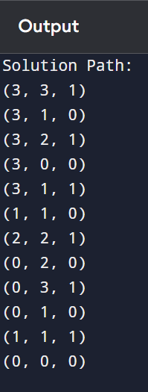

Result
Thus, the Python program to solve the Missionaries and Cannibals Problem using the Breadth First Search (BFS) algorithm was implemented successfully, and the goal state was reached.

